# 

# 

# libXosd Projec

Authors: Derrick Black

Eli Graves

Shane Reynolds

Ainsley Pollitt

Creation Date: 01/24/2022

Last Revised: 01/24/2022

Version: v1.0

**Table of Contents**

Table of Contents................................................................................................................. 1

Revision History................................................................................................................... 3

1. Business Requirements................................................................................................ 4

1.1. Background................................................................................................................... 4

1.2. Business Opportunity.................................................................................................... 4

1.3. Business Objectives and Success Criteria.................................................................. 4

1.4. Customer or Market Needs........................................................................................... 4

1.5. Business Risks.............................................................................................................. 4

2. Vision of the Solution....................................................................................................... 5

2.1. Vision Statement............................................................................................................ 5

2.1. Major Features................................................................................................................ 5

2.2. Assumptions and Dependencies.................................................................................... 5

3. Scope and Limitations...................................................................................................... 6

3.1. Scope of Initial Release................................................................................................... 6

3.2. Scope of Subsequent Releases...................................................................................... 6

3.3. Limitations and Exclusions............................................................................................... 6

4. Business Context............................................................................................................... 7

4.1. Stakeholder Profiles.......................................................................................................... 7

4.2. Project Priorities................................................................................................................ 7

4.3. Operating Environment...................................................................................................... 7

5. Scheduling............................................................................................................................ 8

5.1. Gantt Chart......................................................................................................................... 8

5.2. Key Milestones................................................................................................................... 8

5.3. Resource Assignments..................................................................................................... 8

5.4. Individual Responsibilities.................................................................................................. 8

6. Deliverables.......................................................................................................................... 9

6.1. Software............................................................................................................................. 9

6.2. Documentation................................................................................................................... 9

6.3. Key Presentations.............................................................................................................. 9

**Revision History**

| **Name** | **Date** | **Changes** | **Version** |
| --- | --- | --- | --- |
| D. Black, et al. | 1/24/22 | First Draft | 1.0 |
|  |  |  |  |

# 

# 1. Business Requirements

## Background

libXosd is a project that was initiated as a concept many years ago, but as an open-source piece of software, it has continued to change and entice individuals to add additional features and alter how it operates. The design of libXosd is to display text on the screen, and while the software is based on simple functionality, there are a plethora of different possibilities to improve its utility.

## Business Opportunity

We were given the opportunity to work on this project by our advisor Aran Clauson. He is a user of this specific library and is requesting that we add more features to it in order to help users use the library for more purposes and expand it to make it compatible with more features. In doing this we can complete our senior project which we need for graduation.

## Business Objectives & Success Criteria

The objective of this project is to add multiple features to libXosd. Some of these will include but are not limited to adding support for multiple screens, adding functionality for clocks or other scripts, adding ability to display pixmaps, and adding multiple fonts and colors of text to switch between. The success criteria is completing some of these and making the new features public for all the current users to use.

## Customer/Market Needs

Because libXosd has been untouched and stagnant for many years, there are a wide swath of possible improvements that have not been performed. One in particular is the fact that there is no functionality for multiple screen displays, and rather the libXosd software as it is will only display text on a primary monitor. In general, the need for this project is to have improved functionality for any users that are interested in it.

## Business Risks

Considering that libXosd is an already existing, open-source project, there is care that must be taken to ensure that the functionality it already contains is not altered in any way. Although there is no individual with money staked into the project, it is imperative that anyone who had been using libXosd is not negatively impacted by changes brought forth by the team. Ergo, the largest risk in consideration for the project is the possibility of generating new errors not otherwise present in libXosd and hindering its functionality rather than improving it.

# 2. The Vision of the Solution

## Vision Statement

Using this on screen display library on unix. Users will be allowed to create custom text or even images to display on their screens that will sit on top of the current screen environment which allows easy access to information in one spot that will not disappear while working on other things.

## Major Features

FE-01: Displays text over screen

FE-02: FE-01 compliance with multiple screens

FE-03: Multiple fonts, font sizes, and custom text colors

FE-04: Displaying pixmaps over screen

## Assumptions and Dependencies

Assumptions

* There are users interested in using libXosd
* libXosd has a certain level of extensibility in its current state
* Another team is not already currently further developing libXosd

Dependencies

* The software must be run on a UNIX system
* The user must download the software for use

# 3. Scope and Limitations

## Scope of Initial Release

The initial release will include the following:

* Extension of existing text display functionality to multiple displays
* Enhancements of code clarity
* Improvements on the current software design

## Scope of Subsequent Releases

Subsequent releases may contain additional utilities such as the following:

* Ability to display pixmaps in addition to existing ASCII library
* Ability to display text of multiple font types
* Bug/error fixes
* Optimization to line drawing to use the full screen width

## Limitations and Exclusions

There are very few limitations that we have to do this project but the few limitations we have are pretty big ones. One of them is knowledge, we are not sure if we have all the experience and information needed currently to know how to work on this project but this is something we will learn how to do over time. The other limitation is time, we have a year to finish this senior project so that is about how long we have to fully complete this project.

# 4. Business Context

**Stakeholder Profiles**

| **Stakeholder** | **Major Value** | **Attitudes** | **Major Interests** | **Constraints** |
| --- | --- | --- | --- | --- |
| users | ability to overlay text on multiple displays | ambivalent but willing to use the product as an open source tool | extensibility of text overlay to specific applications | product must be free/open source; product must be somewhat user friendly |
| developers | potential for additional features and utility | interested depending level of clarity and cohesiveness of design | expansion and/or use of software in the creation of a larger project | code must have a high level of readability and extensibility |

## Project Priorities

Things that we must prioritize in this project are implementing the new features. Since this project has already been created and we are just expanding it, the features that we make will be key. We must also prioritize the grouping of our code since it is in C and we lack any Object Oriented Programming language.

## Operating Environment

Establishing a stable operating environment will be critical for improving upon the work done previously for libXosd. The new features that are intended to be implemented, such as multiple display functionality, should not interfere with the previous functionality of the project. As such, the major priority in the development process and in the operating environment is to prioritize maintaining already existing code and to avoid introducing too many alterations to that code. Rather, the development will be more wrapped in creating new features that work in tangent with the current code base.

# 5. Scheduling

## Gantt Chart

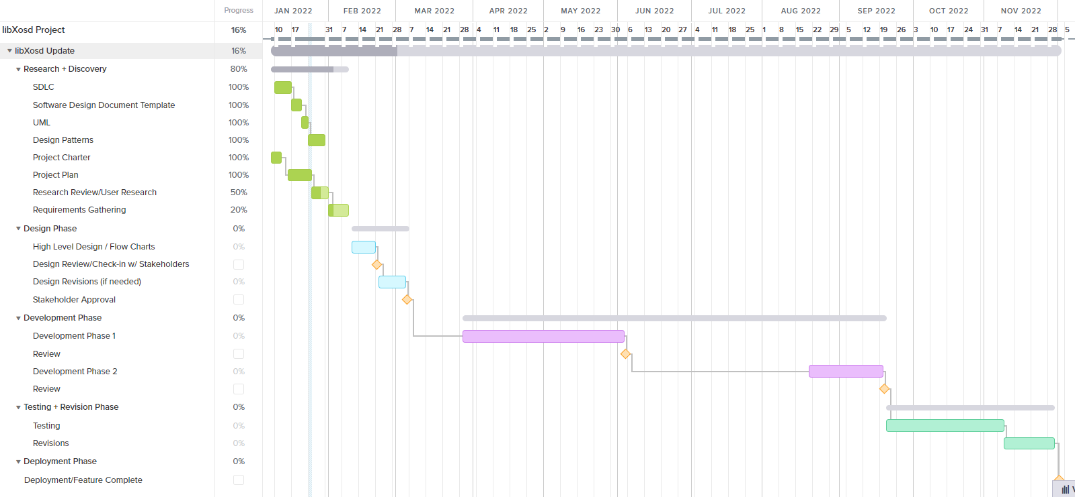

## Key Milestones

* UML Diagram of libXosd repository
* Identification of key features and implementation details
* Implementation of key features
* Testing of key features
* Final version of project

## Resource Assignments

We won’t necessarily be allocating any monetary assets to this project so our only resource is just work time which we will need to manage and allocate for each element of the project as work hours are restricted as we will be spending much of our work time on other assignments that have no relation to the project.

## Individual Responsibilities

Since there are 4 group members we will each be responsible for participating in all work relating to the project. Other than this we don’t have any people currently responsible for any specific parts of the project, although this could change in the future.

# 6. Deliverables

## Software/Hardware

* Updated libXosd application

## Documentation

* Documentation on usage and changes

## Key Presentations

* Presentation discussing project plan and goals
* Presentation demonstrating completed software and all newly added functionality

## Other Deliverables

* Documents pertaining to the planning of the libXosd software